**Data Visualization Digital Assignment – 1**

**Name : Mahesh Jagtap**

**Reg No.24MCS1017**

**Title:** Sales Performance Analysis of a Pharmaceutical Company for 2015-2016

**Executive Summary**

This project plays a crucial role in understanding the sales performance of a leading pharmaceutical company over the years 2015 and 2016. The primary objective is to provide the client with a clear view of sales trends across various regions, tiers, and time frames, allowing for better insight into both successes and areas needing improvement. By focusing on key performance indicators (KPIs) at different levels—national, regional, and territorial—the analysis facilitates a deeper understanding of the factors driving sales growth or decline. This is expected to enhance the decision-making process by providing data-driven insights that are easy to interpret and act upon, ultimately supporting the company in making more strategic and timely business choices.

The tool used for this analysis was **Tableau**, which enabled the creation of interactive and dynamic dashboards. These visualizations included bar charts, pie charts, and quarterly sales breakdowns, all of which provided a detailed exploration of sales trends and performance factors.

**Introduction:**

In today’s competitive pharmaceutical industry, gaining insights into sales performance is vital for optimizing strategies and ensuring growth. This project focuses on analyzing the sales data from 2015 and 2016 to identify trends and performance variations across different regions and customer segments. Understanding these patterns helps the company refine its business approach, address regional disparities, and leverage strengths in high-performing areas.

The sales data includes various attributes such as customer segments, units sold, and total sales across different regions. By exploring this data, we aim to uncover actionable insights that can drive better decision-making, streamline operations, and improve future sales strategies.Through the use of interactive visualizations, this report not only highlights the company’s performance but also identifies areas of concern, such as regions with declining sales or tiers underperforming in certain divisions. These insights are expected to provide a solid foundation for data-driven decision-making moving forward.

### **Problem Statement:**

Project aims to assess the sales performance of a leading pharmaceutical company for 2015 and 2016 by analyzing regional sales trends, identifying contributing factors, and comparing total sales across different regions and customer tiers.

Key objectives include:

1. Evaluating sales differences by region between 2015 and 2016 while identifying states in the East region that experienced declines in sales.
2. Exploring factors influencing regional sales for 2016 and examining which high-tier divisions saw reductions in units sold.
3. Adding a quarter classification to the sales data and analyzing quarterly sales trends for both years.
4. Assessing the composition of quarterly sales across customer tiers.

**Methodology :**

#### **Data Source**

The analysis utilizes a dataset from a leading pharmaceutical company, focusing on sales records for the years 2015 and 2016. Key aspects of the data include:

* **Sales Trends**: Captures sales performance across different regions and customer segments, highlighting trends and patterns over the two-year period.
* **Geographic Insights**: Allows for analysis by various regions and divisions, facilitating an understanding of regional performance differences.
* **Customer Segmentation**: Includes tier classifications, enabling the examination of sales performance across different customer segments.
* **Monthly Data**: Provides sales figures on a monthly basis, facilitating a detailed analysis of seasonal trends and demand fluctuations.
* **Sales Metrics**: Contains both total sales and units sold, allowing for a comprehensive evaluation of revenue generation and product movement.

**Attributes in the dataset include**:

#AccountId #AccountName #Region #Division #City #State #Tier #Month #Sales2015 #Sales2016 #Units2015 #Units2016 #TargetAchieved2015 #TargetAchieved2016

#### **Data Preprocessing**

Data preprocessing was performed using **Tableau**, focusing on ensuring the dataset's quality and preparing it for analysis. The following steps were taken:

**Data Import**: The sales dataset from the pharmaceutical company was imported into Tableau, providing a user-friendly environment for exploration and visualization.

**Data Cleaning**:

* **Identifying and Handling Missing Values**: Missing values were detected, and decisions were made to either exclude those records or use Tableau’s functions to fill in the gaps where feasible.
* **Duplicate Removal**: The dataset was examined for duplicates, which were removed to maintain a clean and accurate dataset.

**Data Transformation**:

* **Reshaping the Data**: The dataset was reshaped as necessary to create appropriate views and facilitate analysis. This included converting data from wide to long formats and vice versa as needed.
* **Adding New Columns**: A new column was created to categorize sales data into quarters based on the month, allowing for better analysis of quarterly sales trends.

**Data Aggregation**: Sales figures were aggregated by relevant dimensions, such as region and tier, using Tableau’s calculation features. This aggregation helped in comparing sales performance effectively across different categories.

1. **Data processing**

* **Creating Pivot Tables**: Pivot tables were created to summarize and aggregate the data, allowing for easier comparisons across different dimensions. This facilitated the analysis of total sales and units sold by region, division, and tier, highlighting key performance metrics for both 2015 and 2016.
* **Developing Visualizations**: Various visualizations were generated, including:
  + Bar charts to compare sales by region for 2015 and 2016.
  + Pie charts illustrating the contributing factors to sales for each region in 2016.
* **Quarterly Sales Analysis**: The newly created quarter column enabled the analysis of sales on a quarterly basis. Pivot tables were used to compare sales figures across quarters for both years, revealing seasonal trends and performance fluctuations.
* **Identifying Trends**: The processed data helped identify key trends, such as regions with significant growth or decline in sales. Specific focus was given to the East region to identify states that registered a decline in 2016 compared to 2015.
* **Calculating KPIs**: Important metrics such as total sales, units sold, and target achievements for both years were calculated using pivot tables. This helped in assessing overall performance and identifying areas that needed improvement.

**Results and Discussion**

The following charts illustrate various aspects of the sales data, providing valuable insights for analysis:

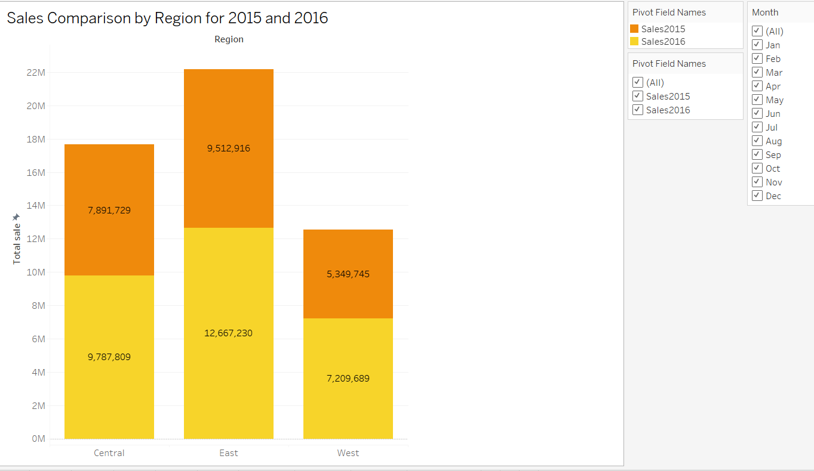

Fig 1.The bar chart compares sales by region for the years 2015 and 2016.

* East Region had the highest sales in both years, with 12,667,230 in 2015 and 9,512,916 in 2016.
* Central Region showed sales of 7,891,729 in 2015 and 9,787,809 in 2016, indicating growth.
* West Region had the lowest sales, with 5,349,745 in 2015 and 7,209,689 in 2016.

Overall, the East region had the highest sales, while the Central region experienced an increase from 2015 to 2016.

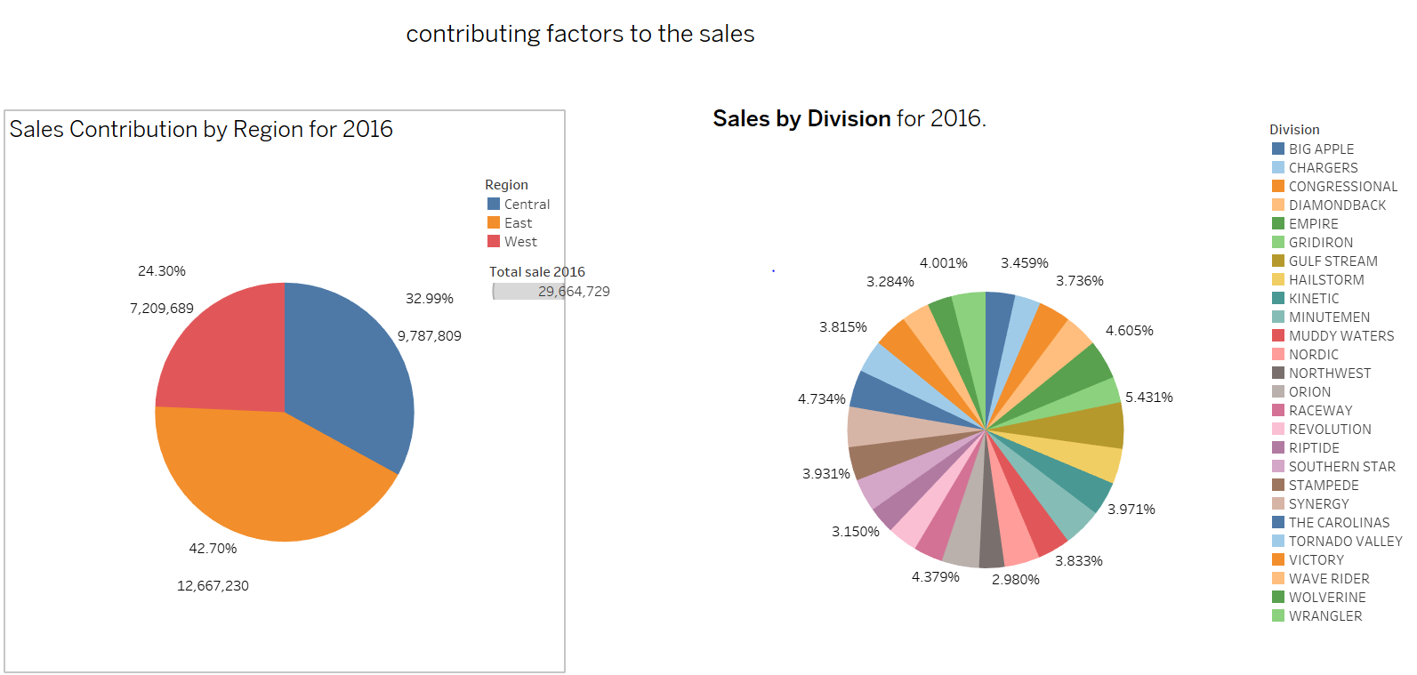

Fig 2. Contributing factors to the sale

In 2016, the sales distribution by region shows:

* East Region: Contributed 42.7% of total sales, amounting to 12,667,230.
* Central Region: Made up 33% of sales, totaling 9,787,809.
* West Region: Accounted for 24.3% with sales of 7,209,689.

The total sales for 2016 were 29,664,729. In terms of divisions, the pie chart indicates a diverse range of contributions, with no single division dominating. The largest division, Big Apple, contributed 5.431%, while several others contributed between 2.98% and 4.73%. This suggests a balanced performance across various divisions, highlighting the importance of multiple product lines in overall sales.

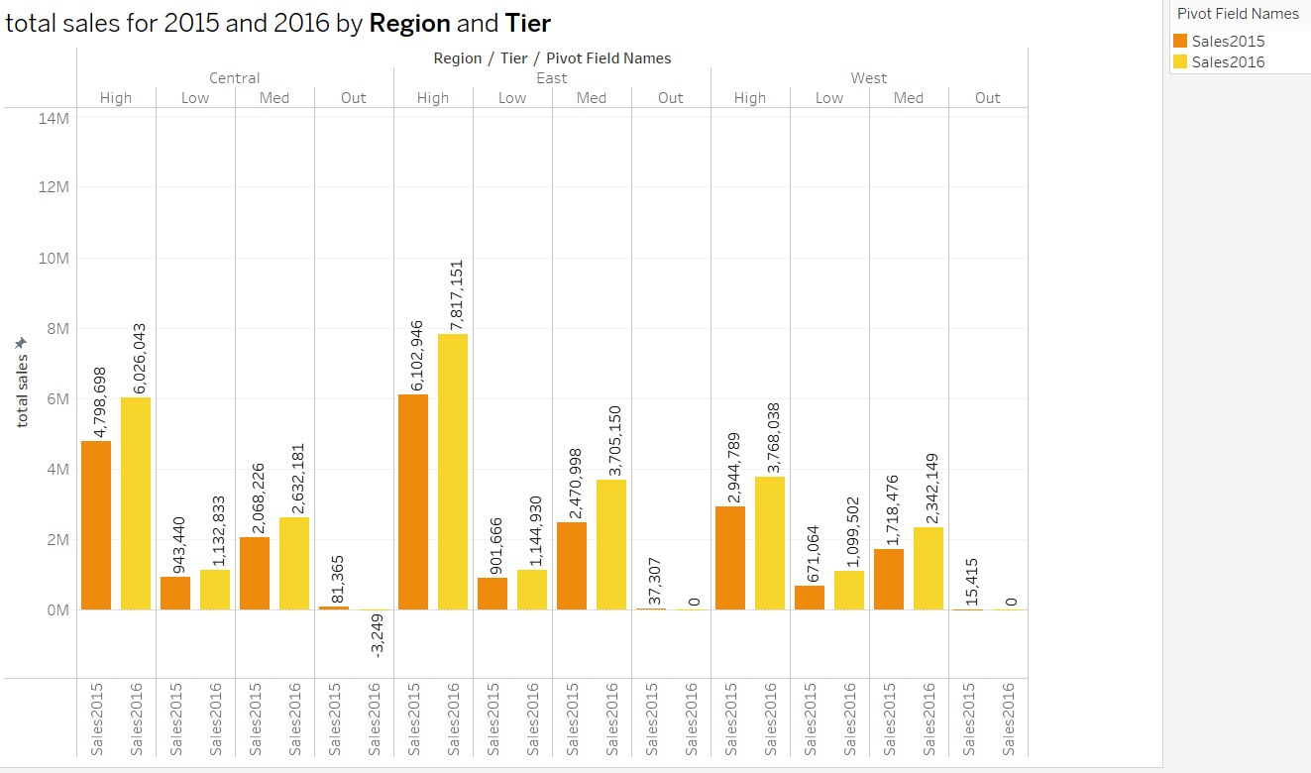

Fig 3. total sales for 2015 and 2016 across different regions and tiers

* Above bar chart compares total sales for 2015 and 2016 across different regions and tiers. It shows that:
* The East region consistently outperformed the West region in total sales for both years.
* The ‘High’ tier had the highest sales figures in both regions for both years.
* There was a noticeable increase in sales from 2015 to 2016 in almost all categories, except for ‘West-Med’ where there was a slight decrease.
* The ‘Out’ tier had no recorded sales in any region for either year.

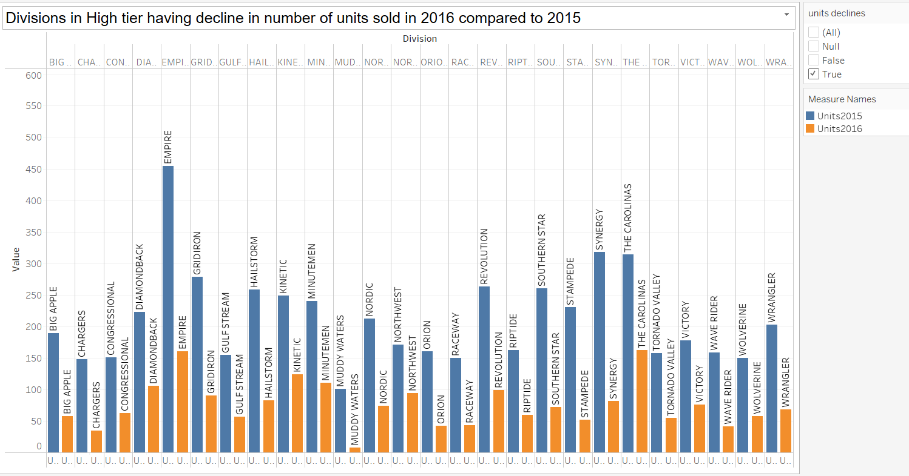

Fig 4. Division vs total units sold

**Above chart represents** divisions in the high tier experiencing a decrease in unit sales from 2015 to 2016.

EMPIRE and DIAMONDBACK divisions saw particularly sharp declines.

Some divisions, like RIPTIDE, SOUTHERN STAR, and THE CAROLINAS, maintained their sales levels.

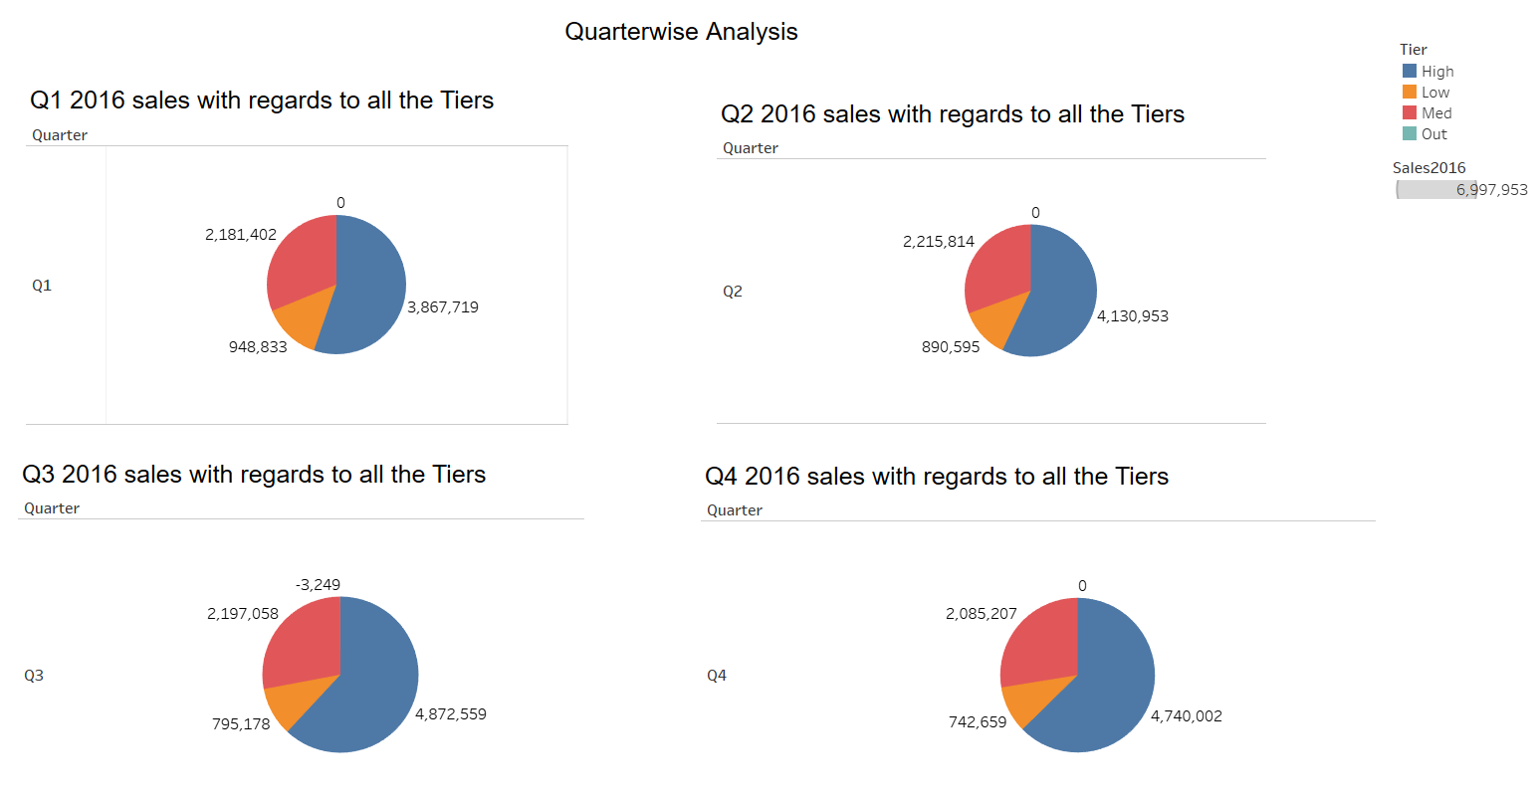

Fig 5 . quarter wise sales

The image presents a quarterwise analysis of sales data for four quarters in 2016, categorized by tier (High, Low, Med, and Out). Each quarter is represented by a pie chart, visually illustrating the proportion of sales contributed by each tier.

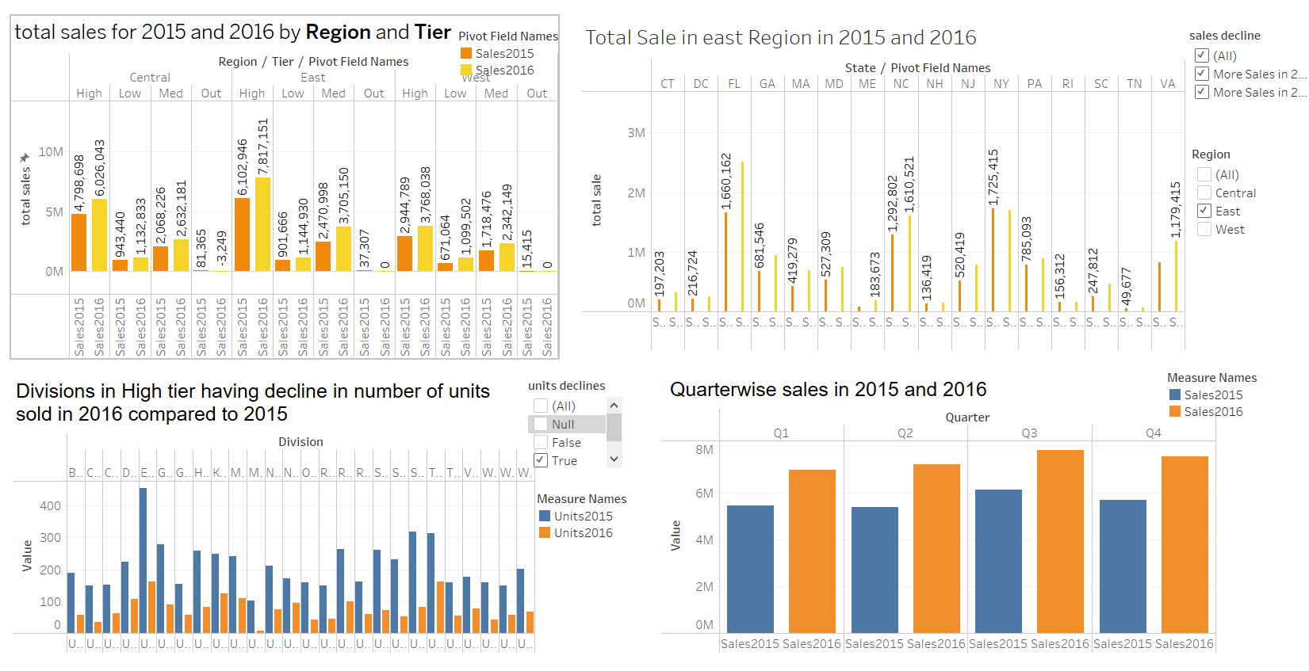**Final Dashboard:**

Fig. 6

**Key Observations:**

1. Throughout all four quarters, the High tier consistently represents the largest portion of sales, indicating its significant contribution to overall revenue.
2. The Low tier's share of sales has a decreasing trend across the quarters, suggesting a potential decline in sales from this segment.
3. The Mid tier maintains a relatively consistent share throughout the year, indicating a moderate contribution to overall sales.
4. The Out tier, representing a very small proportion of sales, remains relatively stable throughout the year.
5. While the High tier remains dominant, there are noticeable fluctuations in the proportions of the other tiers across quarters, suggesting variations in sales performance within each segment.

**CONCLUSION:**

In conclusion, the analysis of the 2015 and 2016 sales data revealed key insights into the company’s performance. While overall sales increased, certain regions, such as the East, experienced declines, indicating areas that need targeted strategies for improvement. The High-tier customer segment emerged as a major contributor to revenue, emphasizing the value of focusing on high-performing segments. Additionally, quarterly trends showed seasonal fluctuations, suggesting the need for strategic timing in sales and marketing efforts. By addressing underperforming regions and tiers, the company can optimize its sales strategies and drive future growth.